**VIRTUAL LEARNING REVIEWS AND SUGGESTIONS (2)**

|  |
| --- |
| TEACHER |

**1.On add parent lets add a drop down for selecting a student (incase the student is already on the system)**

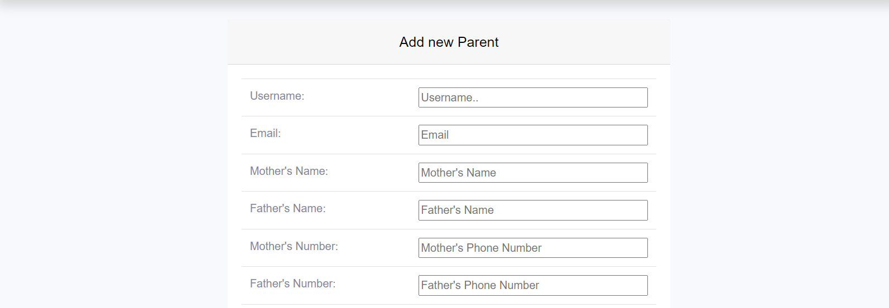

**2.Check this on submit button on edit parent**

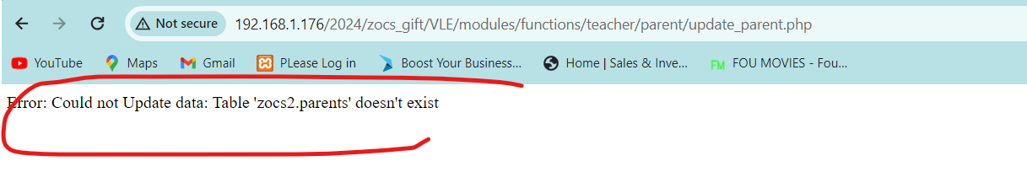

**3.Unable to delete edit student**

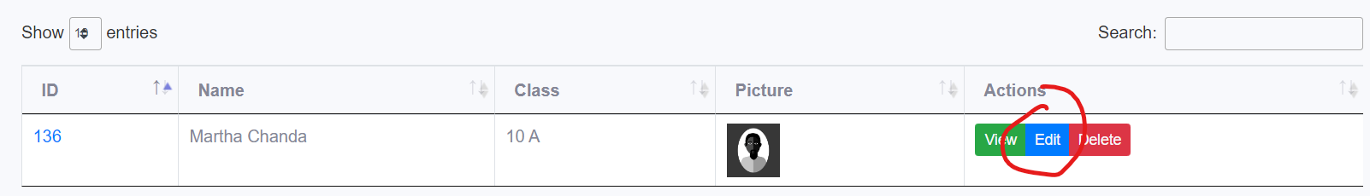

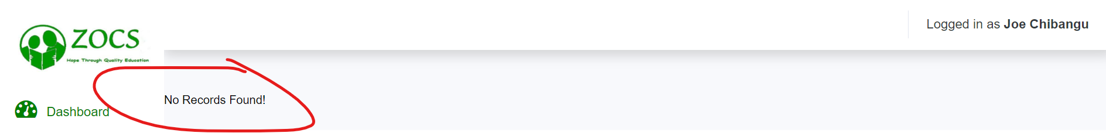

**4.When adding student I should be to save without uploading a profile pic**

**5.Change it to raise a query**



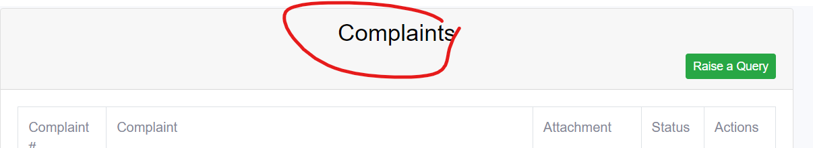

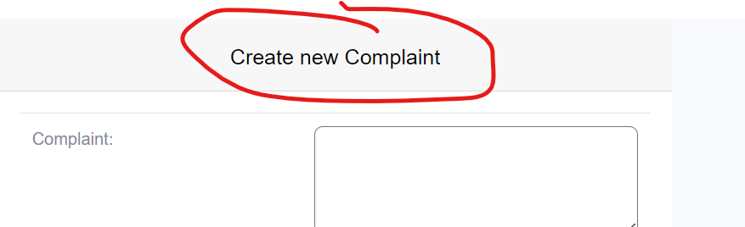

**6.When creating a query lets add an option where you can send the query/complaint to (DRC or to ZOCS)**

|  |
| --- |
| PARENTS |

**2.Check this on parent edit profile**

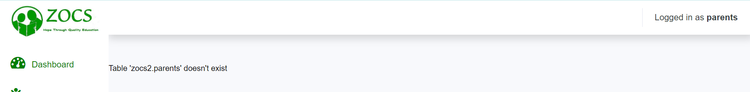

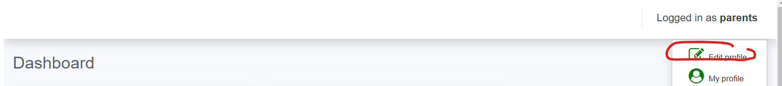

**2.lets remove this if the parent wont be using this**

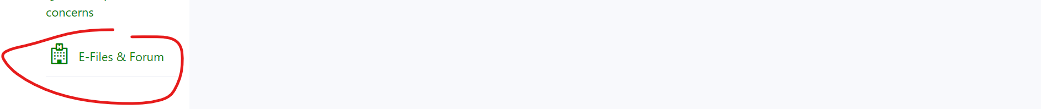

|  |
| --- |
| ZOCS |

**1.ZOCS also needs to make announcement and able to assign a teacher to a school**

**2.Add menus on dashboard**

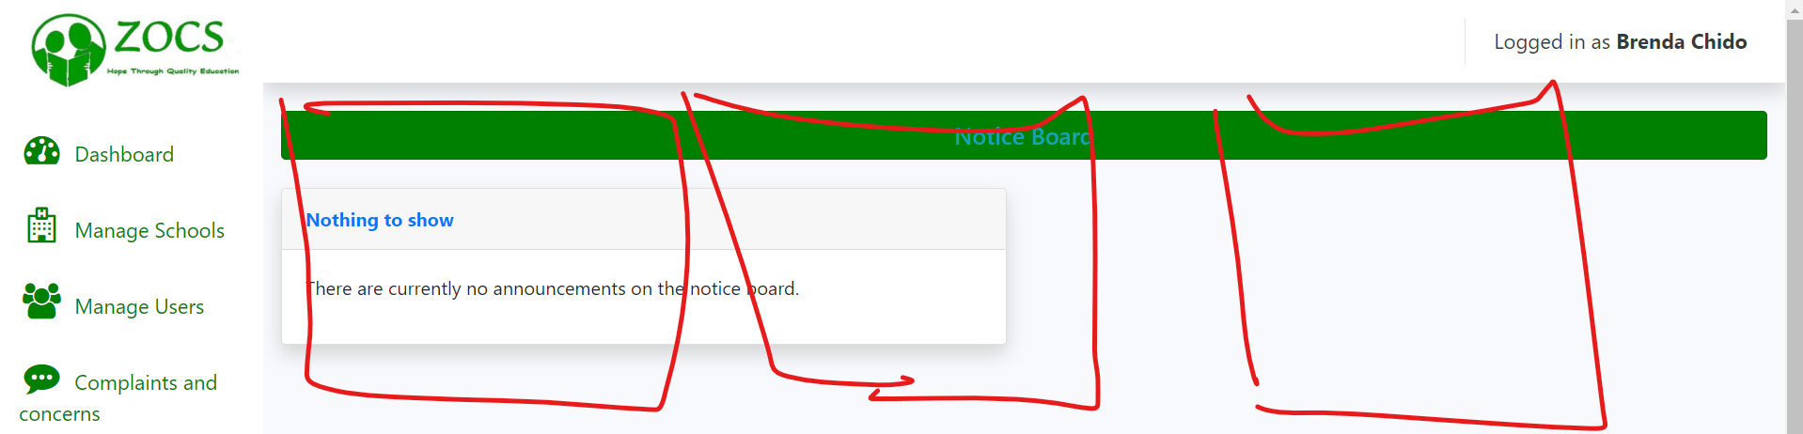

|  |
| --- |
| DRC |

**1.Drc to interact with the teachers within that district**

**2.all dashboards to look uniform**

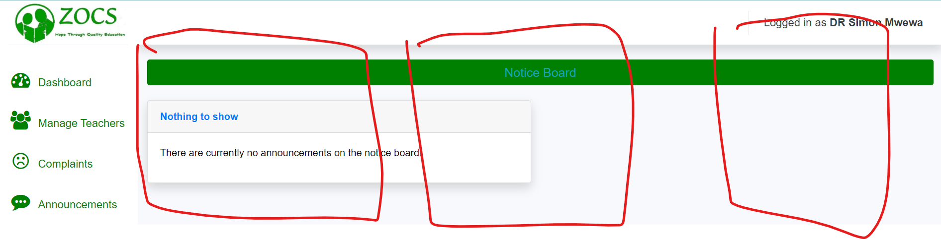

**3.i think drc should also be able upload documents (for teachers or public)**

|  |
| --- |
| LANDING PAGE |

**1.To change the second image on scroll**

**2.it woud make sense to show the authors/person who uploaded documents**

